Name: Mohd Zunaid Al Ameen Ansari

Date 17/10/2022

**Assignment 1**

**Connect and disconnect with login Access**

* What happens when you login a non-existent users or username?
  + Provide Screenshot and What you understand, explain in short brief?

Step 1: Logging out from my account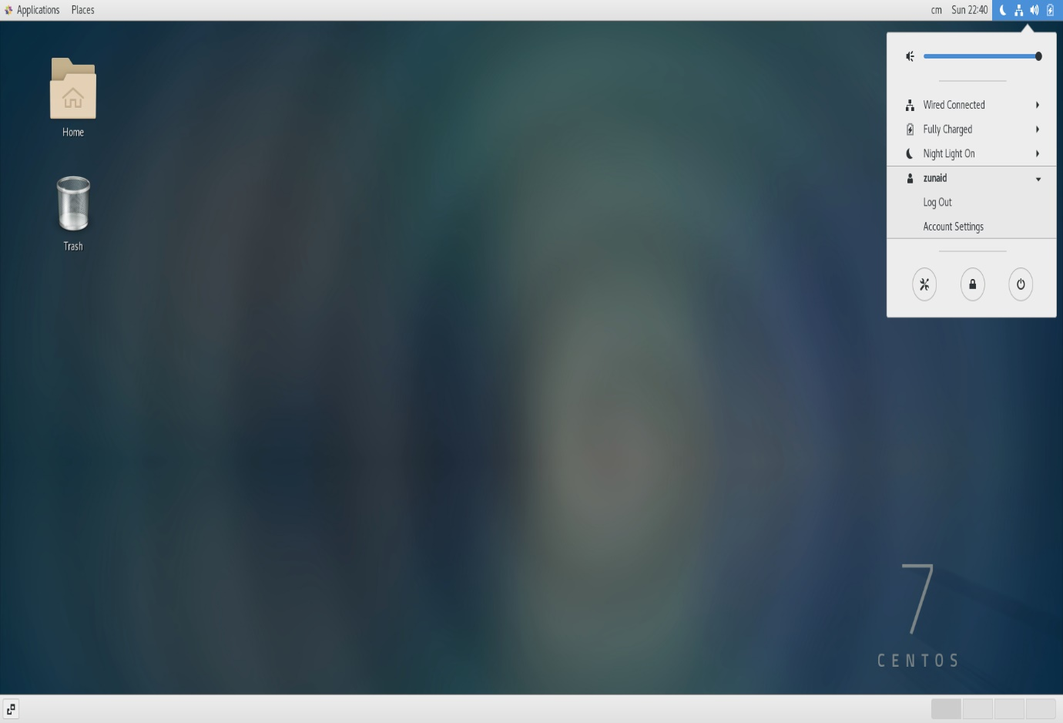

Step 2: Trying to log in using wrong user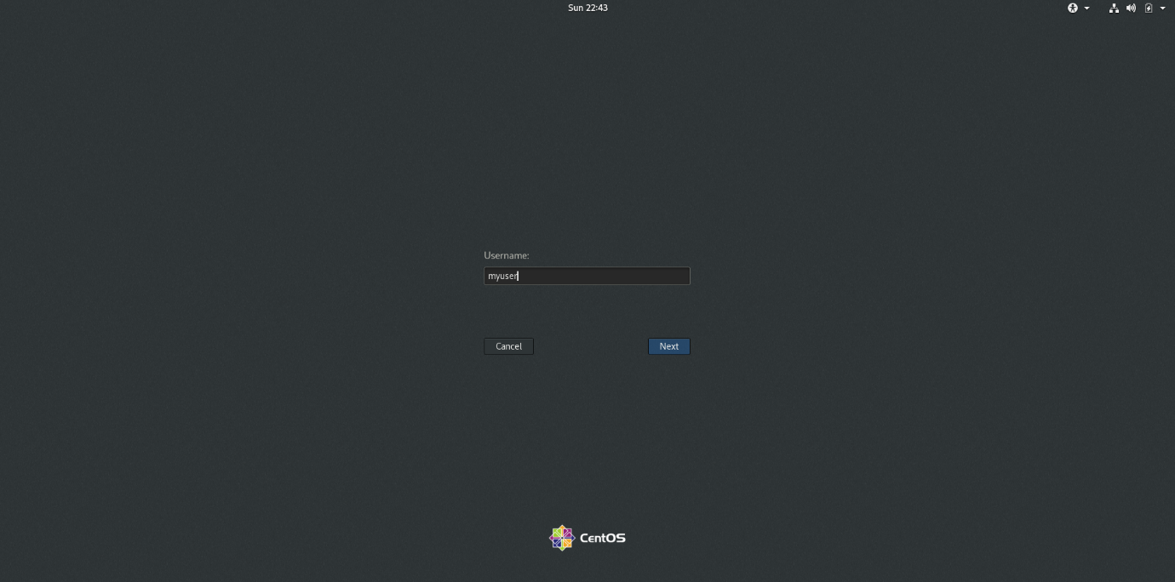

Step 3: It will proceed for the password without checking for the username is present in the main account or not.

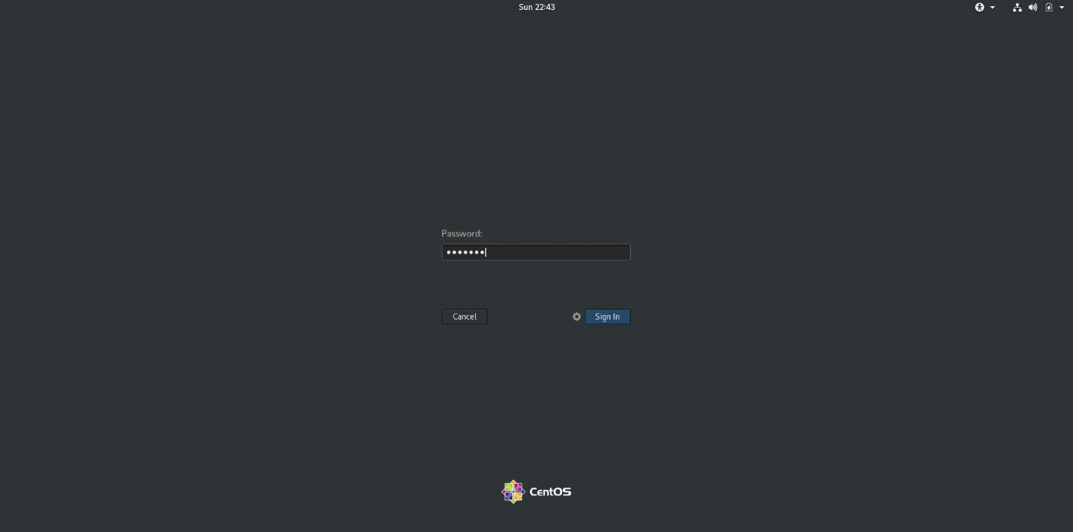

Step 4: It will now check for username and match the password and as the username is wrong and so as password too. It will show the same problem and do not allow to sign in.

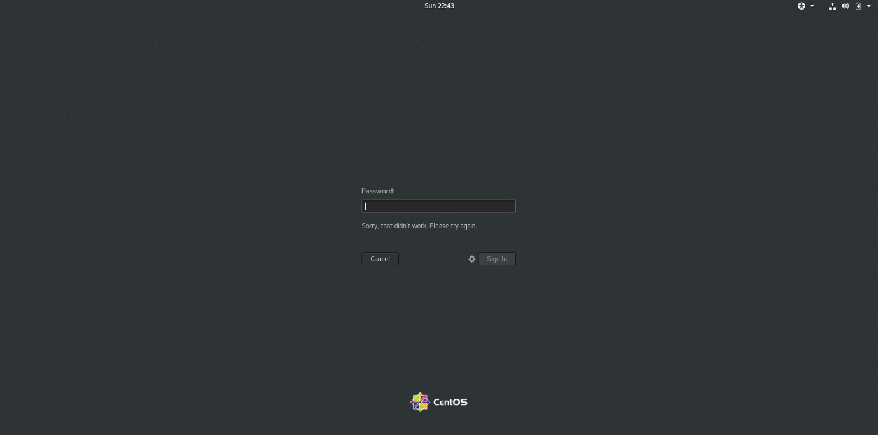

**Assignment 2**

**Password changing**

* Login into your account and then change password?
  + Change your password into ***IneuR0n#42*** and hit the **Enter** key
    - Explain what happen and give screenshot?
  + Try again to change password but use like password ***1234*** or ***abcd***
    - Explain what happen and give screenshot?
  + Try again to change password but now don’t use any password just hit **Enter** key
    - Explain what happen and give screenshot?

Solution

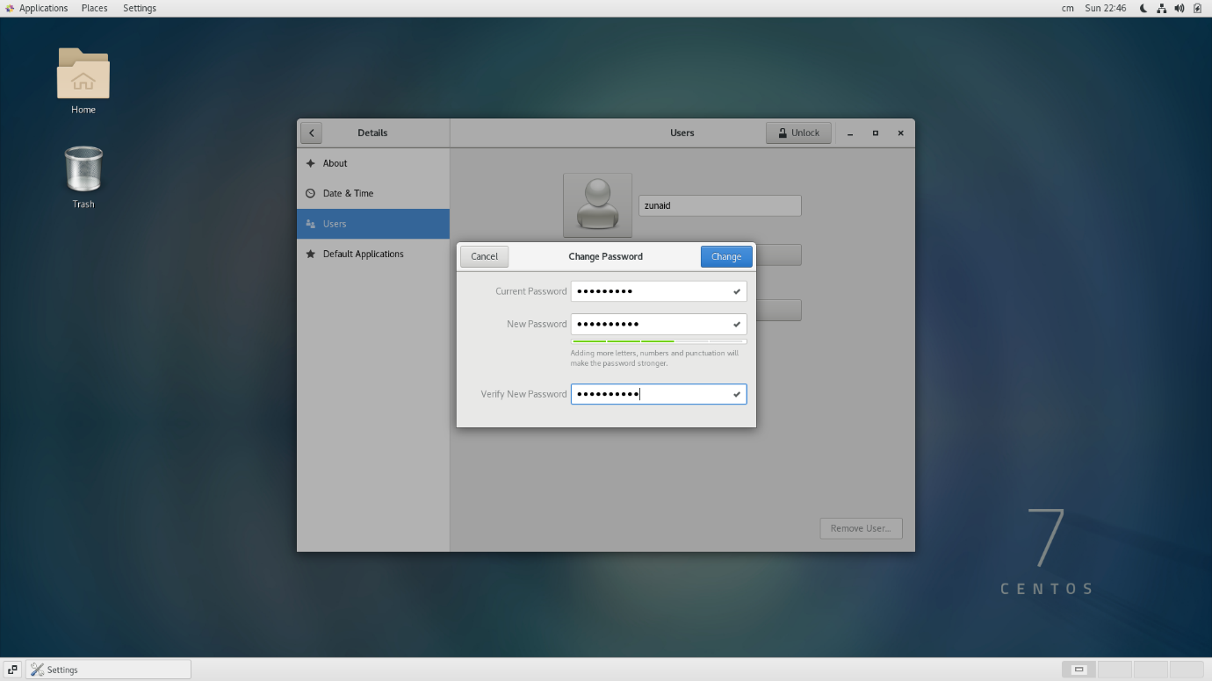

It is asking to fill current password before allowing to set new password so that to avoid unethical account access.

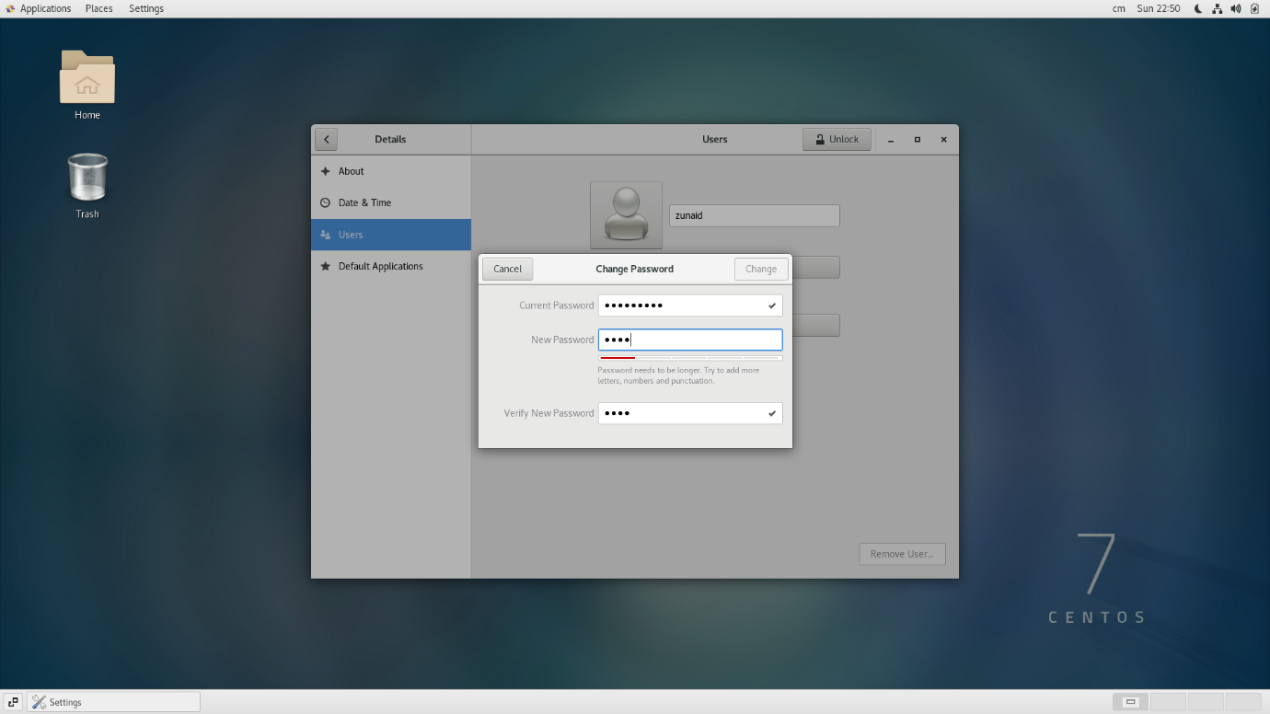

Trying to change password to 1234 but it is not allowing to change because this password is weak.

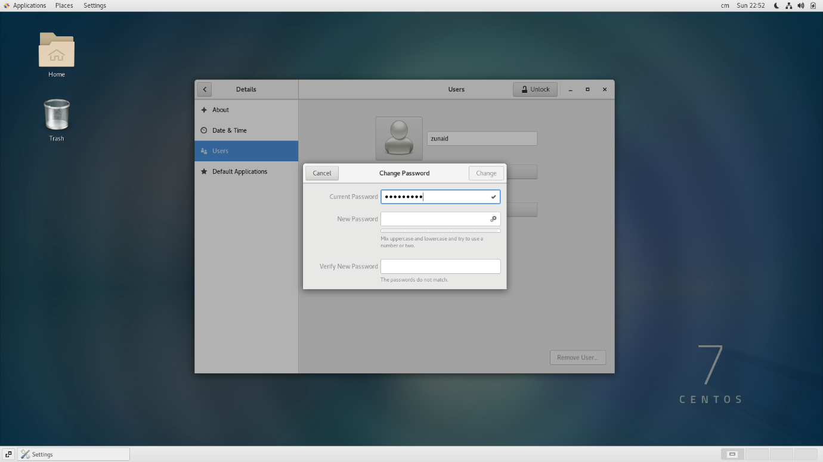

It will not allow Empty password which means password is mandatory in linux(CentOS) which provide security to the user account to some extent.

**Assignment 3**

* Enter the command **cd /** and then **ls** and then hit **Enter** key
  + Take screenshot and explain what output we got?

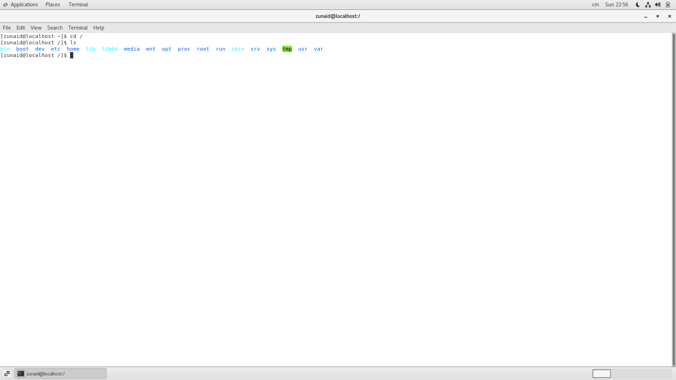

cd / command change directory to root directory

after which ls command will print the list of all directories and file inside /

* Enter the command now **cd /home** and then hit **Enter** key

Do **ls,** provide screenshot and explain what is **/home** directory used for?

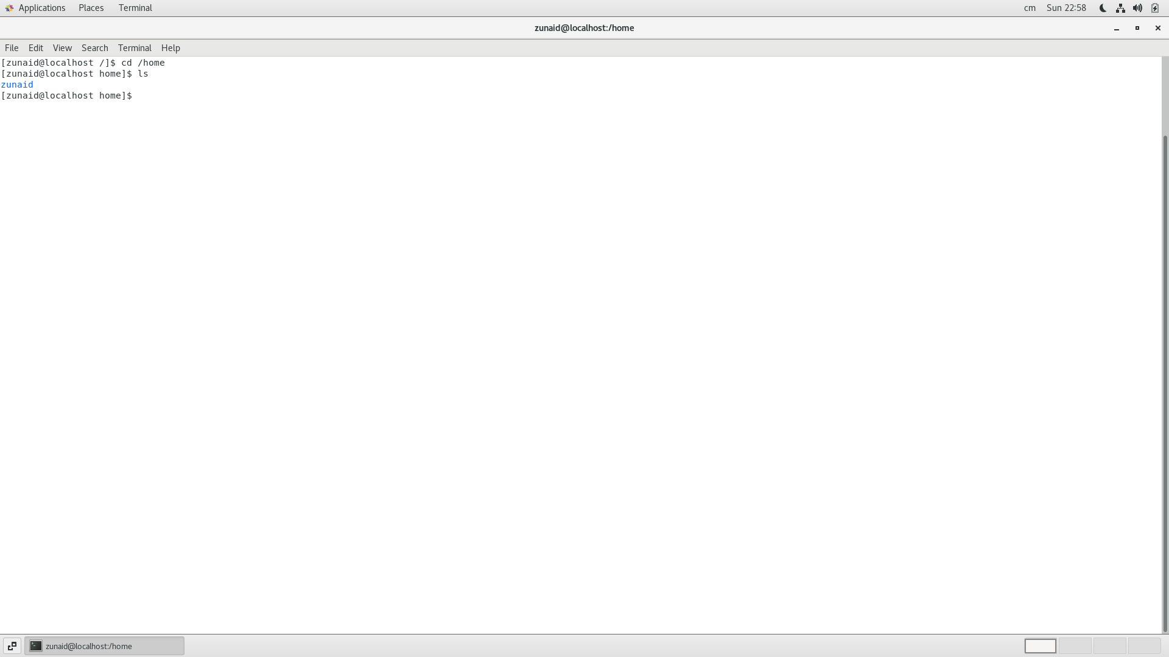

cd /home will take from / to home directory which is present in / after which ls is printing the file/directory which is present in home directory. Directory with username in this case.

* Enter **cd ..** and hit **Enter** key [ *Note: here we have space after cd then use double dot*]
  + Check what happen and give screenshot?

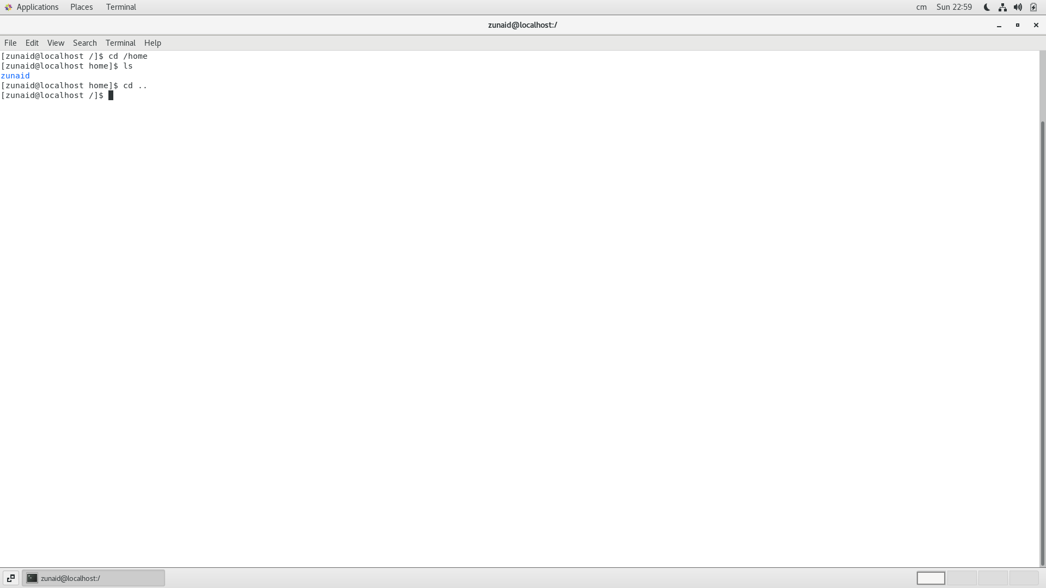

cd .. is taking to the previos directory from the current directory/file.

* Now type **cd /root** and then hit **Enter** key

Do **ls,** check any output we have on screen if yes then take screenshot?

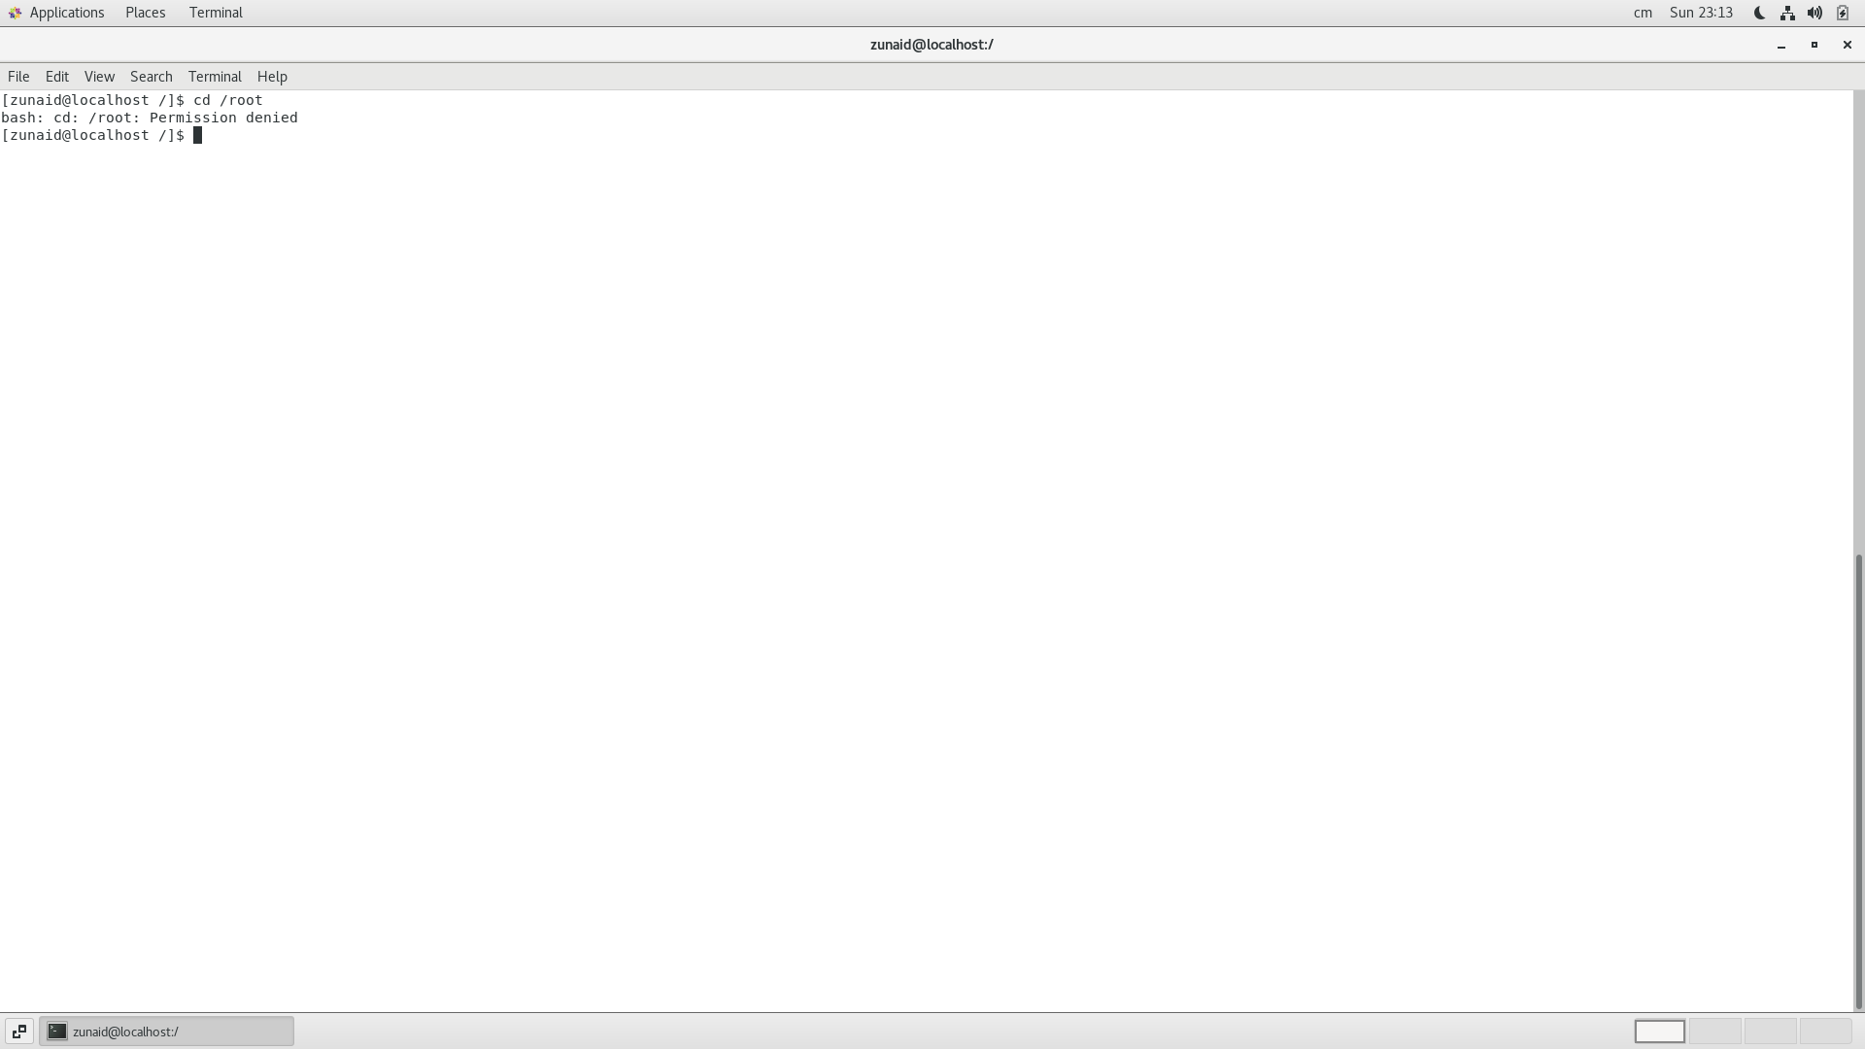

cd /root command taking us to the root which is present inside / but the permission is denied because only root user is allowed to go inside it. /root is home director for root user.

**Assignment-4**

**Working with File Listing**

* Go to **cd /etc** and type **ls**
  + Take screenshot and explain what files you have seeing?
  + Take screenshot and explain what different output you found compare to previous command you used?

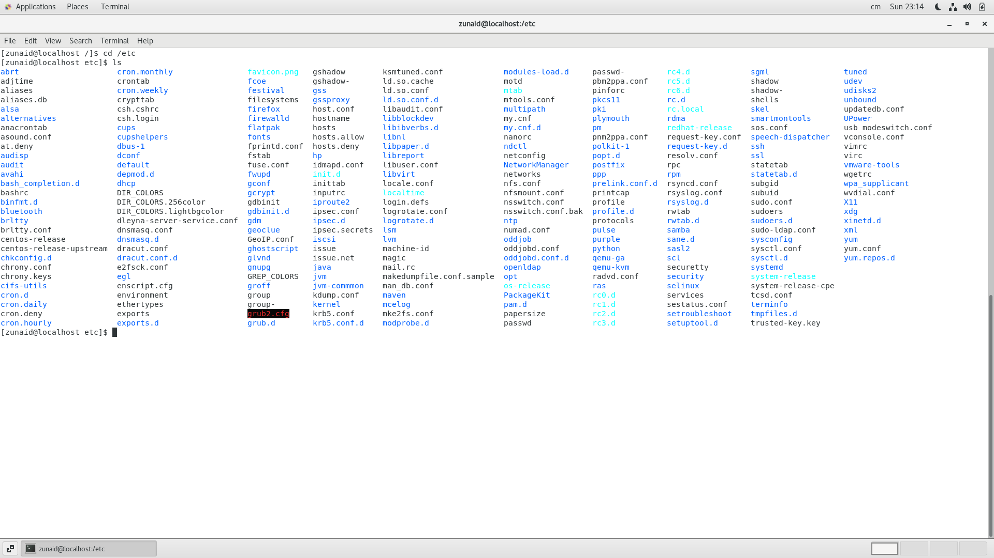

cd /etc command taking to etc directory which is present inside / directory

ls command is showing all the directories and files present inside etc

difference between root and etc is /etc contains host specific system configuration does not need permission to access while /root is home directory for root user and require permission to get access.

* Then type **ls -al** and hit **Enter** key
  + Take screenshot and explain what new file or directory you found?

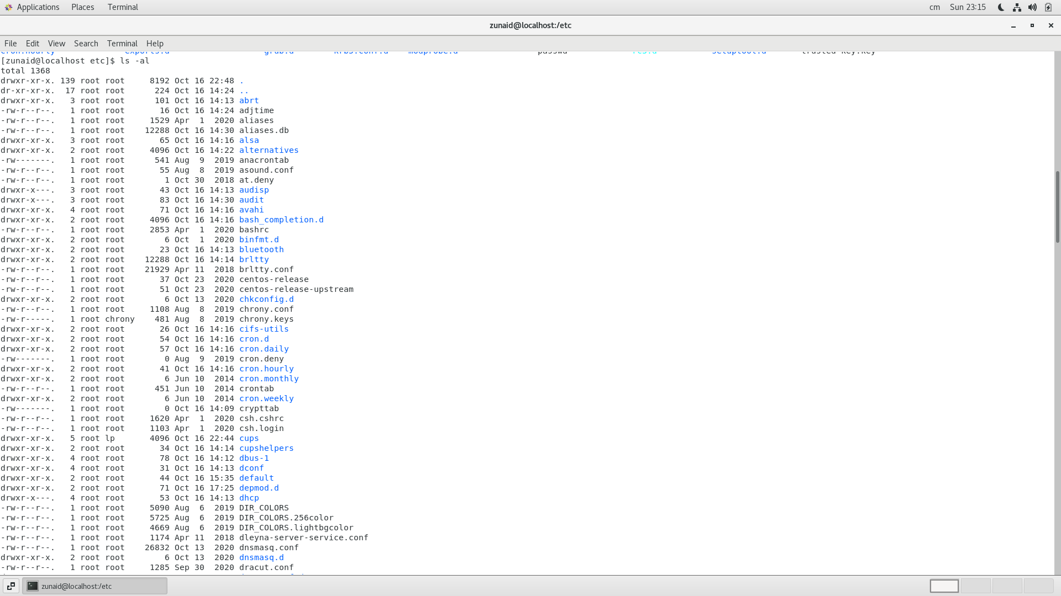

ls -al

-a is used so that it will not ignore entries starting with ‘**.**’

-l to show in long listing format.

It is showing the access of each file and the time it was created.

* Then use **ls -i** and hit **Enter** key
  + Now see what different output its shows and take screenshot?

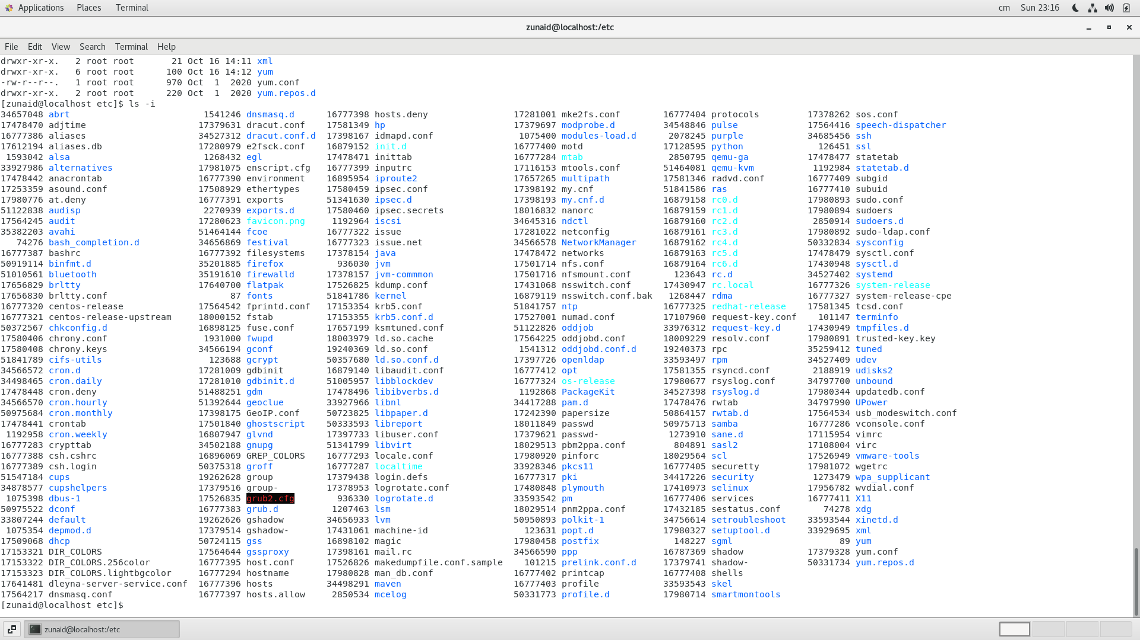

It is printing the list of directories and file with their respective index numbers.

* Then use **ls –help** and see other options about **ls** command

Explore it and try with other attribute we can use with **ls** command

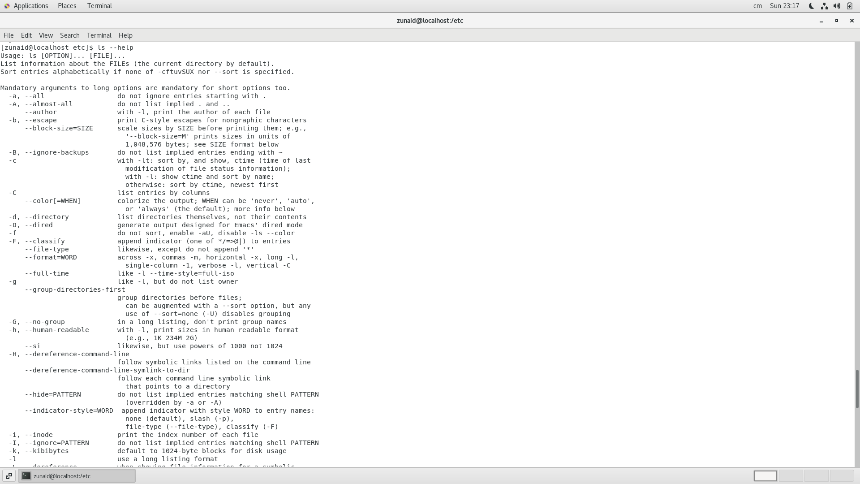

It provides all the other command which can be used with ls and a short description about the command.

We can use –help command with any command to find their use with other commands

**Assignment 5**

**Know where you are and where you working**

*Here we use* ***pwd, cd and ls*** *as combine task to understand where you working on terminal and how you can switch from one directory to another one.*

* Open terminal after restart the linux

Check which location you working, type **pwd** and take screenshot

* Now use **cd /var** and hit **Enter** key
  + Do **ls,** and see what output comes, give screenshot?
* Do explore other help options of each command to learn more other things we can do with these commands

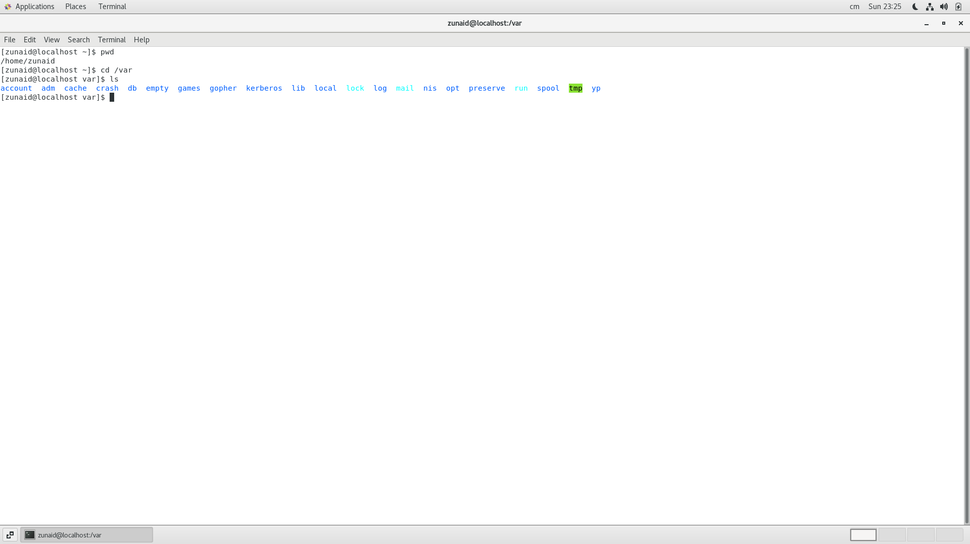

pwd print name of working directory

cd /var change the directory to var directory

ls print the list of all directories present in /var directory.